23AID498 – Project Phase 1
Project Diary (Code Review)
Date of meeting with the Guide: 09-10-2026

Work planned for the coming week |  | - Further development and refinement of the UI.  - Implementation and testing of the remaining UI functionalities.
 |  | - Finalisation of the research paper draft and project documentation.
 |  | - Preparation of the research paper for conference submission.
Work completed during the previous week |  | - Conducted a code review with the guide and explained the functionality of each module.  - Discussed the project workflow and implementation approach based on the feedback received.
 |  | - Implemented and integrated the basic UI functionalities into the project.
Pending work |  | - Completion and testing of the remaining UI functionalities.  - Finalisation of the research paper and project documentation.  - Submission of the research paper to a suitable conference.

Remarks by the Guide:

Conducted the code review and discussed about the paper
Weekly Performance Rating (0–5) –5

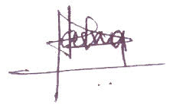
9/10/26
Guide's Signature with Date:

